PRDA – 01 Profit Analysis

Task:
- Get data from the database with the given credentials.
- Perform Regression Analysis for the given data to identify how the money spent on Marketing, R&D, and Administration is affecting the company’s Profit. Predict the Profit for the below-given input features.

R&D Spend | Administration | Marketing Spend | Profit
21892.92 | 81910.77 | 164270.7
23940.93 | 96489.63 | 137001.1

- Visualize the data using Tableau /PowerBI and derive insights about all the features provided and give your inputs/suggestions to the company.

About Dataset:
This particular dataset holds data from 50 startups in New York, California, and Florida. The features in this dataset are R&D spending, Administration Spending, Marketing Spending, location features, and Profit.
Link for dataset:
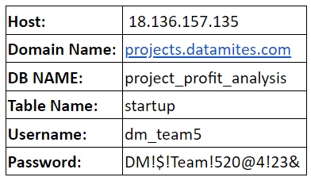

Attribute Information:
- R&D spending: The amount that startups are spending on Research and development.
- Administration spending: The amount that startups are spending on the admin panel.
- Marketing spending: The amount that startups are spending on marketing strategies.
- State: To which state that particular startup belongs.
- Profit: How much profit that particular startup is making.
Students must submit the following:
- Dataset Source Confirmation
(Select whether the dataset was sourced from Database or CSV)
- PPT Upload
(Includes problem understanding, regression analysis, visualizations, insights, and recommendations)
- Regression Output (Optional)
(Regression result table, screenshot, or text summary)
- Visualization Screenshots
(Screenshots from Tableau or Power BI dashboards)
- Analysis Report File
(.doc or .txt file containing detailed analysis and conclusions)

